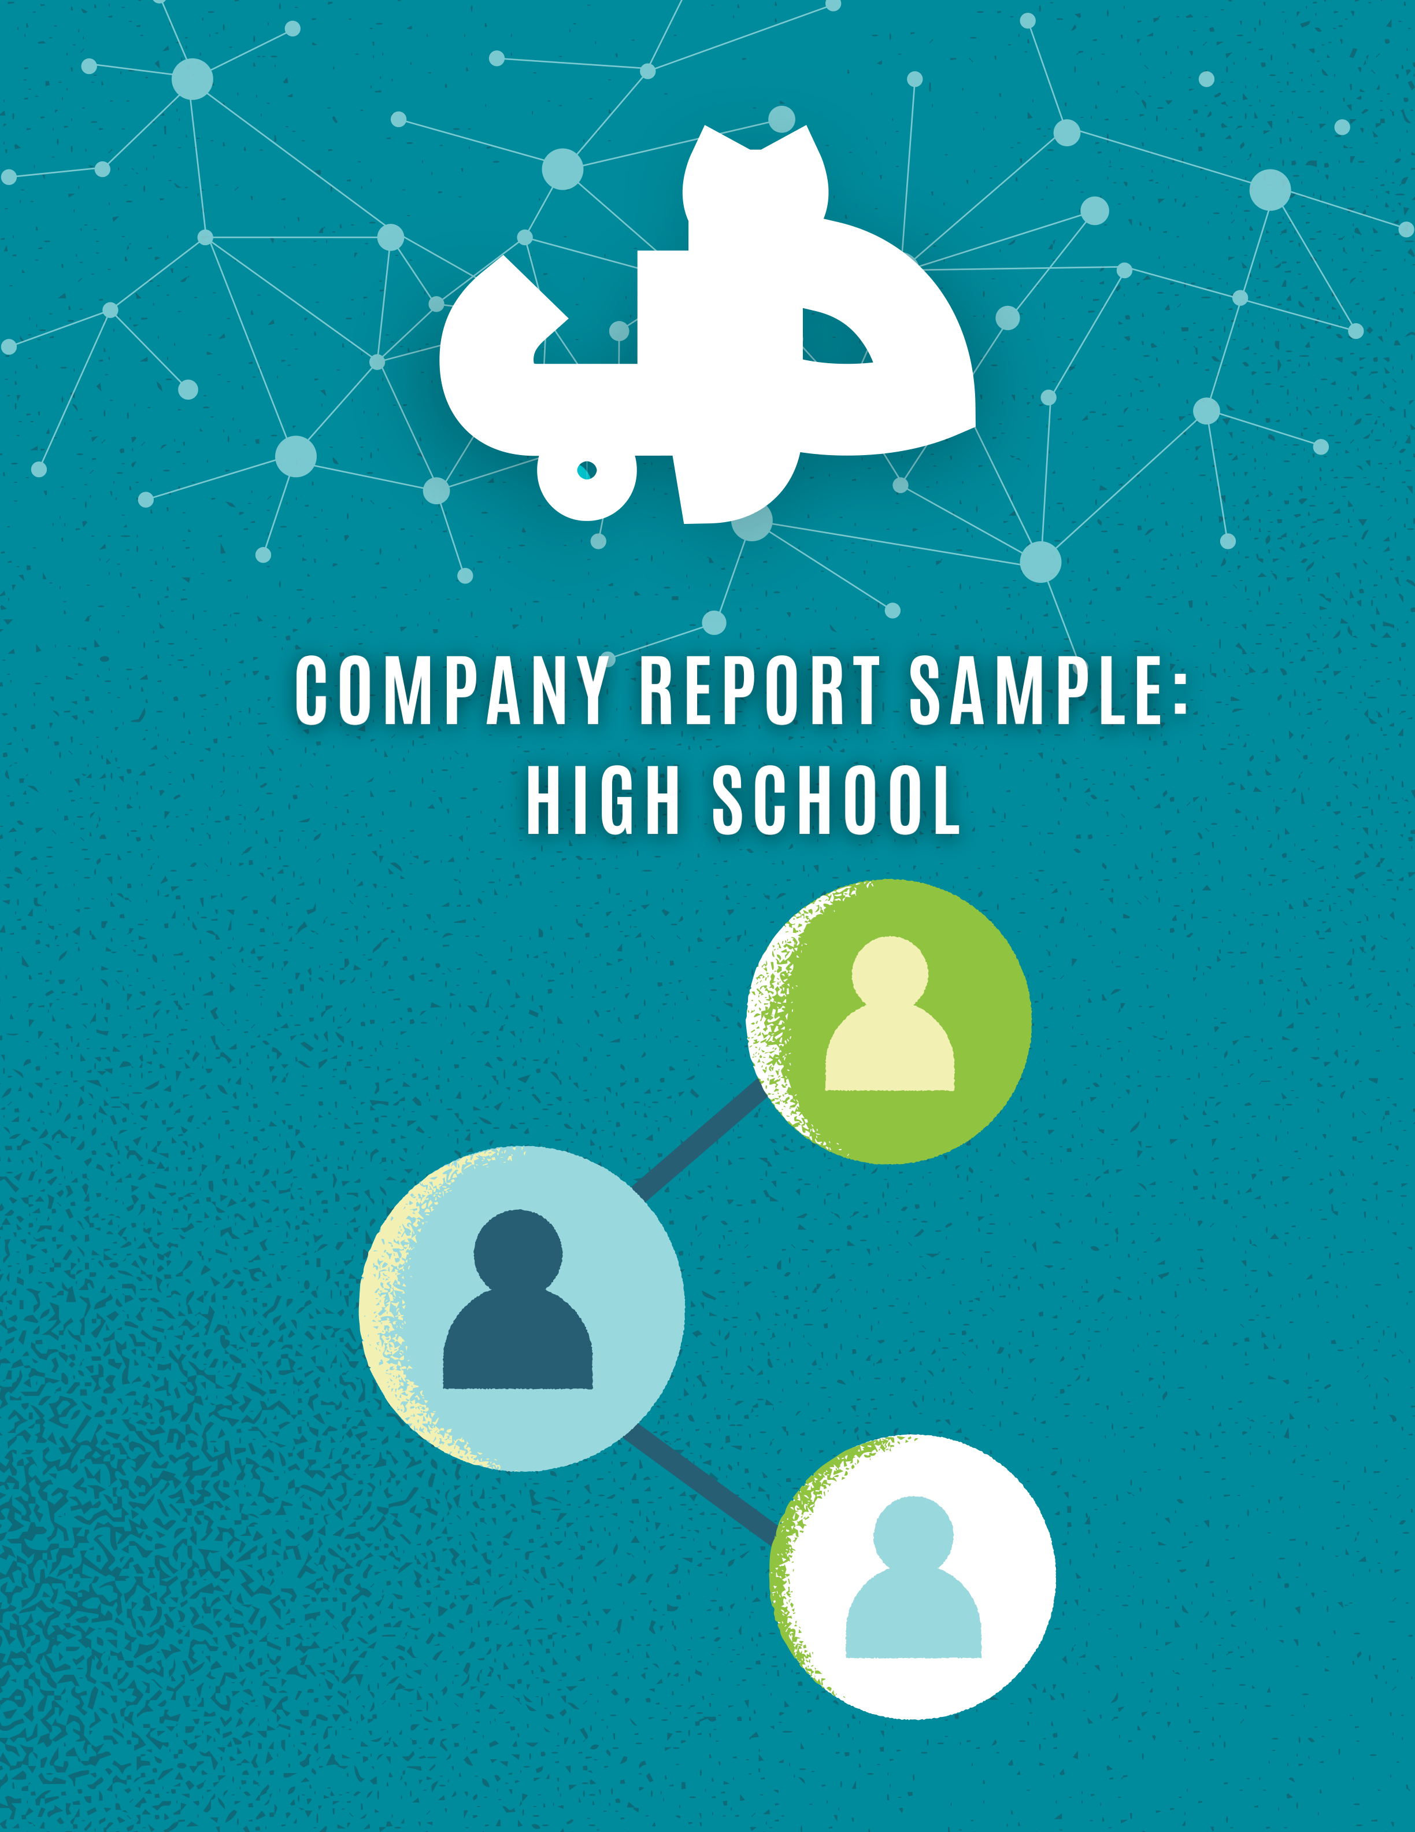

دِّرب دِّرب

BRIDGING THE GAPSS

**TABLE OF CONTENTS**

|  |  |
| --- | --- |
| CEO Note  Executive Summary  Aim of the Company Report  Company Structure  Darrb Team  Company Mission, Vision and Values Product Development  Market Research  Production Report  Marketing Report  Sales Report  Financials Report  Business Plan  Project Management (IMBEDDED) SDG & Track Connection  Reflection | 1  2  3  3  3  4  5  6  7  8  10  11  13  14  14  14 |

دِّرب دِّرب



|  |  |
| --- | --- |
| CEO’S NOTE | دِّرب دِّرب |

Dear Shareholders, At Darrb, we deeply value the trust and support you have placed in our company, which has been instrumental in laying th e foundatio n fo r ou r journey . You r initia l contribution s hav e bee n pivota l in establishing our platform, enabling us to fulfill our mission of empower ing non-degree holders in the workforce.

Thanks to the collective efforts of our shareholders and the transparency demonstrated by our customers, Darrb has achieved remarkable success . You r guidanc e ha s bee n invaluabl e i n ensurin g th e sustainabilit y o f o ur operations and strengthening the interests of all stakeholders.

Darrb acknowledges and appreciates your ongoing commitment to our cause, which goes beyond mere financial support. Your contributions ar e instrumental in helping us save lives by creating meaningful employme nt opportunities for non-degree holders.

Warm regards,

Ahmad Al-Hassan   
CEO

|  |
| --- |
| **1** |



**EXECUTIVE SUMMARY**دِّرب دِّرب

***Business Identity***   
Darrb is a pioneering online employment platform dedicated to empowering non-degree holder youth. Our mission is to bridge the gap between talent and opportunity, providing a supportive ecosyste m where aspiring professionals can thrice and succeed. Through innovative technology and personaliz ed support, we create pathways to meaningful employment, unlocking the potential of every individual we ser

***The Problem***   
Young adults who have not pursued higher education and lack access to quality employment opportunities face challenges in securing diverse short-term and long-term jobs. This demographi c ofte n lack s resource s fo r caree r guidanc e an d professiona l development , an d the y ma y als o lac k t he too ls a nd knowled ge necessa ry f or effecti ve self-brandin g. The se facto rs contribu te to a reducti on in their employability leading to high rates of unemployme

***The Solution***   
Darrb has developed a comprehensive online platform that offers personalized short- and long-term job opportunities, tailored career guidance, professional development resources, and self-branding tool s targeting non-degree holder youth

The Product Offering

Our platform includes the following features: Job Matching and Networking Opportunities: Th e platform features job matching algorithms th at connect users with relevant job openings ba sed on their profiles and preferences. Additionally , it could facilitate networking opportunities all owing users to expand their professional networ ks and access hidden job markets. Personalized Career Guidance: Utilizing algorithms and asse ssments, the platform provides personaliz   
ed career recommendations based on the user   
's skills, interests, and goals. Professional Development Resources: The platform offers a w ide range of educational resources, including on line courses, tutorials, and webinars, covering

Company   
Performance

Darrb has aimed to contribute to reducing the unemployment rates amongst non-degree holde r youth thus adding to decent work and econom ic growth. The Product development t   
eam implemented advanced algorithms and u   
ser-friendly interfaces to optimize the platf   
orm, ensuring seamless user experience. -The Mark eting Development team conducted thorough market research and worked on a marketing strate gy that put Darrb on the map of employment net works. -The Finance team developed financial models, managed budgeting and implemented financial controls and risk management strate gies. -The Sales team identified target custom er segments and developed sales strategies to p

topics such as resume writing, interview preparat enetrate

ion, networking skills, and industry-specific

knowledge. Self-Branding Tools: Users can   
access tools and templates for creating profession al resumes, cover letters, and online portfol   
ios to effectively showcase their skills and exper iences to potential employers. Additionally, t he platform provides guidance on personal  
 branding strategies. Continuous Suppo   
rt and Mentorship: The platform offers ongoing support and mentorship programs, connectin g users with experienced professionals who can provide guidance, advice, and encourageme

Financial   
Performance

Darrb has successfully provided 12,008 job listings in the last year. With a price of 40USD per listing , the company’s overall annual revenue w   
as equivalent to 480,320 USD. Based on the cost of 33USD per listing and a profit of approximately 17% the net profit was equivalent to 84,056

|  |  |
| --- | --- |
| nt throug | **2** |

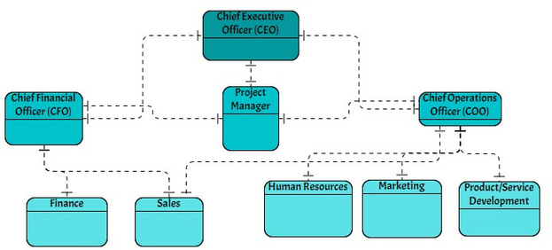

دِّرب دِّرب

**AIM OF THE COMPANY REPORT**

The aim of this company report is to provide stakeholders, including shareholders, investors, employees, and other interested parties, with comprehensive information about the company's financial performance, operational activities, achievements, challenges, and future outlook. It serves as a testament for Darrb’s commitment to transparency, accountability, and communication, allowing stakeholders to assess the company's health, make informed decisions, and understand its strategic direction. Additionally, this company reports may be used to attract investors, comply with regulatory requirements, and demonstrate corporate governance practices. es in securing diverse short-term and long-term jobs. This demographic often lacks resources for career guidance and professional development, and they may also lack the tools and knowledge necessary for effective self-branding. These factors contribute to a reduction in their employability leading to high rates of unemployment.

**COMPANY STRUCTURE**

Figure 1. Company Structure

**DARRB TEAM**

|  |  |  |  |  |  |  |  |  |  |  |  |
| --- | --- | --- | --- | --- | --- | --- | --- | --- | --- | --- | --- |
| **Finance Team** | | | | | **Executive Team** | | | | **Marketing Team** | | |
| Director: | | | | Aisha Al Mansouri | CEO: | | : Ahmed Al Hassan | | Director: | | Yasmin Al Khalidi |
| Team Members: | | | | | CFO: | | Mohammed Saleh | | Team Members: | | |
| 1. | | Omar Khalifa | | | 1. | Hassan Al Saleh | |
| COO | | Fatima Abdullah | |
| 2. | | Mariam Al-Farsi | | | 2. | Noura Al Hamadi | |
| **Product/Service** | | | | | **HR Team** | | | | **Sales Team** | | |
| **Development Team** | | | | | Director: | | | Khalid Bin Said | Director: | | Amira Al Sabah |
| Director: | | | Abdulrahman Al Ghazali | | Team Members: | | | | Team Members: | | |
| Team Members: | | | | | 1. | Layla Al Abed | | | 1. | Faisal Al Qasimi | |
| 1. | Noor Abdullah | | | | 2. | Ali Al Mahmoud | | | 2. | Sara Al Masri | |
| 2. | Hadi Al Maktoum | | | |

|  |  |
| --- | --- |
| Project Manager: Team Members: | **Project Management Office**  Salma Al Jabri  Noor Abdullah/Abdullah Al Fahim/ Salma Ahmad |

|  |
| --- |
| **3** |



دِّرب دِّرب

OUR VALUES

|  |  |  |  |  |  |  |
| --- | --- | --- | --- | --- | --- | --- |
| **Inclusivity** | **Innovation** | **Empowerment** | | **Collaboration** | **Integrity** | **Imapct** |
| DARRB MISSION | | | | DARRB VISION | | |
| "To empower young unemployed | | | "Our long-term vision is to establish ourselves as the | | | |

|  |  |
| --- | --- |
| adults without university degrees through innovative technology  solutions and comprehensive  networking platforms, fostering  economic empowerment and social inclusion." | preeminent global leader in youth employment  networking solutions. We aspire to revolutionize the  accessibility and effectiveness of employment  opportunities for young adults without university degrees, thereby shaping a future where every individual can  embark on a fulfilling and prosperous career journey." |

|  |  |
| --- | --- |
| |  | | --- | | **4** | |

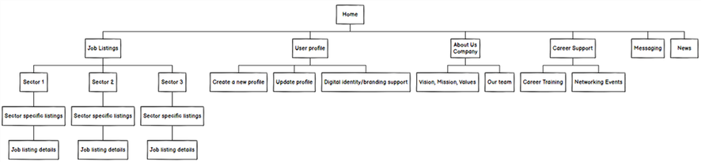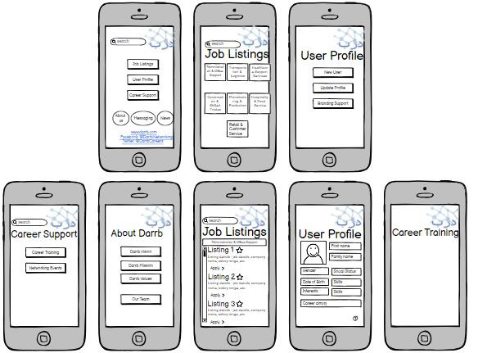

دِّرب دِّرب

**PRODUCT DEVELOPMENT**   
**Abdul Rahman Al-Ghazali**

Based on the market and user research, the product development team decided on launching the platform with a focus on seven job sectors: Admin & office support, transportation & logistics, healthcare support services, construction & skilled trades, manufacturing & production, hospitality & food services and retail and customer service. The platform was developed to be both accessible through a variety of devices (laptop, iPad, mobiles). The first step in the production of the platform was determining a structural hierarchy for the platform.

Figure 2. Platform structure

The wireframe design followed the structure above. This went through several iterations before deciding on the most efficient and intuitive structure.

Figure 2. Platform wireframe

|  |
| --- |
| **5** |



دِّرب دِّرب

|  |  |
| --- | --- |
| **MARKET RESEARCH**  **Yasmin Al-Khalidi**  After analyzing the online employment market, we identified three main competitors. Those competitors were analyzed and three market gap s were identified. Those were used to construct the unique selling point f or Darrb platform. In accordance to our value of inclusivity  and empowerment, we also conducted thorough user research to enable u s to design a user centered platform. An empathy map was cr |  |

|  |  |  |  |
| --- | --- | --- | --- |
| eated accordingly. | | | |
| **Competitor 1:** | |  | | --- | | **Competitor 2:** | | | **Competitor 3:** |
| Strengths: | Strengths: | | Strengths: |
| - Extensive job listing |
| - Make potentially incredibly | |
| - provides professional networking | - Global reach |
| valuable business connections | |
| - User friendly interface |
| with connections | - Network with dozens of people at | |
| - Company reviews |
| - provides valuable job | once using Shapr direct messages. | |
| - Mobile compatibility |
| opportunities | - Exposure to new markets by using | |
| - Resume posting |
| - Professional branding options | the Shapr Teleport function. | |
| - Learning Opportunity along with | - Search for potential investors, | | Weaknesses: |
| Insights Management | clients, business partners, | |
| employers at a fraction of the | | | - Job scams |
| Weaknesses: | price of LinkedIn Sales Navigator. | | - overwhelming job options |
| - presents spam and unsolicited | Weaknesses: | | - limited direct employer |
| interaction |
| messages | - limited direct employer | |
| - Competition: Popular job postings |
| - Time consuming | interaction as it connects with | |
| on Indeed can attract a large |
| - Limited personalization features | individuals rather than businesses | |
| - Targets well established | - highly susceptible to scammers | | number of applicants, increasing |
| competition for those positions. |
| professionals or young adults with | and multilevel marketing (MLM) | |
| - Limited Networking Features |
| impressive CVs and educational | - Connects people according to city | |
| - Incomplete Job Listings |
| background | which might limit exposure to | |
| - Focus on Entry to Mid-Level Jobs |
| certain job opportunities | |
| Market Gaps | | Unique Selling | |
| **Gap 1:** An employment networking  platform tailored to facilitate connection s and opportunities for individuals in nic he or specialized industries/jobs with a hig her level of inclusivity.  **Gap 2:** An employment networking platform that offers short term jo b opportunities. | | Point (USP)  Darrb addresses the following:  Targeting low established individuals without university degrees or wor k experience Short term job  opportunities platform Career  coaching opportunities within the same platform | |

**Gap 3:** A platform that targets low  
 established individuals that do not have   
a university degree or any work   
experience.

|  |
| --- |
| **6** |

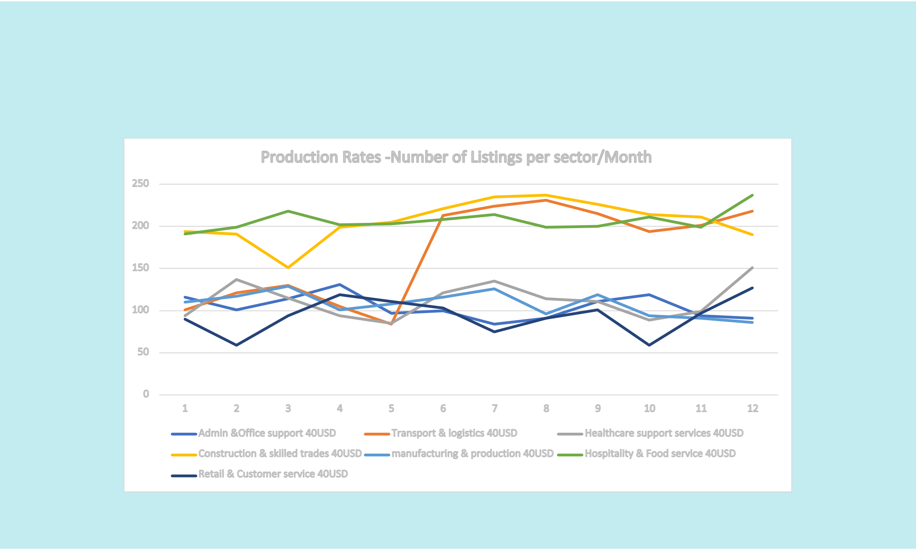

دِّرب دِّرب

**PRODUCTION REPORT**   
The figure below shows the production timeline leading up to the launch of the platform.

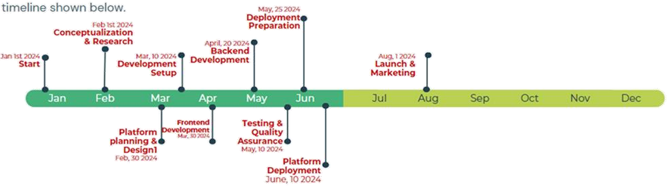

Figure 2. Timeline

**Based on the market and user research, the platform was launched within 7 specific sectors as per the following graph. This graph has also helped us identify employment peak periods per sector. For example, Transportation and logistics had a noticeable peak between May and June. This is attributed to the beginning of the summer vacation for the majority of the local schools, hence an increased role for transportation.**

Production Rates -Number of Listings per sector/Month

250

200

150

100

50

|  |  |  |  |  |  |  |  |  |  |  |  |  |
| --- | --- | --- | --- | --- | --- | --- | --- | --- | --- | --- | --- | --- |
| 0 | 1 | 2 | 3 | 4 | 5 | 6 | 7 | 8 | 9 9 | 10 | 11 | 12 |
| Admin &Office support 40USD | | | Transport & logistics 40USD | | | | Healthcare support services 40USD | | |
| Construction & skilled trades 40USD | | | manufacturing & production 40USD | | | | Hospitality & Food service 40USD | | |

Retail & Customer service 40USD

Figure z. Listings per sector on Darrb

User registration: 7651 users registered throughout the first year Total job applications: 3700 job applications (almost 50% of registered users) Successful employment: 1440 successful employment, 1% included employers recruiting the same individual for

|  |
| --- |
| different short-term posts. |

|  |
| --- |
| **7** |



دِّرب دِّرب

|  |  |
| --- | --- |
| **MARKETING REPORT**  **Yasmin Al-Khalidi**  Based on thorough market and user research, we worked on empathy maps analyzing our target market. After which, our marketing tea m worked on the branding of the company and the platform, deciding on communication channels that we used to advertise and market Darrb. |  |

Target Market Darrb's core demographic

EMPATHY MAP

|  |  |  |
| --- | --- | --- |
| comprises young adults aged 18-26 | "I've applied to so many jobs, but | "Will I ever find a job that values |
| , encompassing individuals of bo |
| my experience and abilities?" "I |
| th genders who have recen | no one seems to give me |
| s there something wrong with |
| a chance." |
| tly completed high school and pos |
| me that's preventing me f |
| “prove my skills and capabilities." |
| sess "I wish I had the opportuni |
| rom getting hired?" "How |
| ty to limited professional experience. | "It's frustrating to see my peers |
| am I supposed to support mysel |
| These users seek assistance in | with degrees getting ahea |
| f and my family without a |
| d while I'm stuck in this cycle." |
| refining their skill sets an |
| stable income?" |
| d identifying suitable employme |

nt opportunities or industries alig ned with their interests and capabilit ies. Moreover, they express a desir e for mentorship and supp   
ort in navigating the complexities of the job market, including gui dance on effective self-presen   
tation to prospective employers. Add itionally, many of these indi   
viduals are inclined toward   
s short-term employment engage ments as they embark on their jou rney of career exploration and development.

**Promotion**

**Non-degree**

**holder**

**unemployed**

Apply for various job **youth**  Frustration:

opportunities, even if they ar Feeling

e outside of their desired field. Se overlooked and undervalued

ek out vocational training progr in the job market. -Insecurity

ams or certification course : Doubting one's abilities a nd self-worth due to repea s to improve skill sets. Network ted rejections. -Anxiety: Worr with friends, family, and com ying about the future and fina

munity members to explore potent ncial stability without a steady income.

ial job leads or opportunities.

Gamification Challenges: Introduce gamification elements to **Social Media Utilization**

make the job search process more engaging and rewarding fo r users. The developers created challenges, quizzes, and digit al scavenger hunts within the application where users can e arn points, badges, or rewards for completing tasks, applyin g to jobs, or referring friends.

Promote Job Listings and Features: Regularly shared job listings, company profiles, and platform features on the social medi a channels. Used eye-catching visuals to attract attention a nd encourage users to explore opportunities on your platform.

Use Hashtags Strategically: Utilized relevant hashtags to incr

**Advertising**  ease the visibility of our posts and reach a broader aud

Targeted Social Media Campaigns: Run targeted advertising campaigns on social media platforms such as Facebook , Instagram, and Twitter. Use advanced targeting options to reach specific demographics, job titles, industries, or intere sts relevant to the target audience. Geo-Targeted Ads: Utilize geo-targeted advertising to reach users in specific location s or regions where there is high demand for emplo   
yment opportunities. Tailor the ad content and messaging to a ddress local job market trends and preferences.

ience interested in topics related to employment,   
career development, and industry-specific trends. Researched t rending hashtags and incorporate them into our content strate gy. Host Q&A Sessions and Webinars: Hosted live Q&A sessions/ webinars on platforms like Facebook Live, Instagram Live. Thes e sessions covered topics such as resume writing tips, interview strategies, and industry-specific insights, positioning our p latform as a valuable resource for job seekers

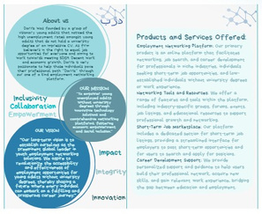

دِّرب دِّرب**SWOT ANALYSIS**

|  |  |  |  |
| --- | --- | --- | --- |
| **Extensive Job Listings:** | **Limited User Base:**Initially | **Market Expansion:** | **Economic Instability:** |
| The platform offers a wid | targeting youn | Diversifying the targe | Economic downturns o |
| e range of job opportuniti | g unemployed no | t audience to inclu | r market disruptions m |
| es across seven differ | n-university degree holde | de university graduates | ay lead to reduced hir |
| ent sectors, caterin | rs may limit the platfor | and mid-career professio | ing activities by employ |
| g to diverse user prefer | m's reach and divers | nals could broade | ers, affecting the deman |
| ences and skill sets. | ity, potentially excluding | n the platform's user ba | d for job listings and |
| **Digital Branding and** | other demographic se | se and increase its | posing financial challenges |
| gments seeking emp |
| **Career Coaching:**BB | market potential. | for the platform. |
| y providing digital brandi | loyment opportunities. | Strategic Partnerships: | **Regulatory Changes:** |
| ng services and car | **Dependency on** | Collaborating with | Changes in labor laws, data |
| eer coaching to regist | **Employers:** | educational institutions, | protection regulations, or |
| ered users, the pla | The platform's revenue | government agencies, and | industry standards could |
| tform enhanc | model relies primarily on | industry partners can | necessitate compliance |
| es the employabi | fees | amplify the platform' | efforts and impose |
| lity of candidates and ad | from companies and | s reach and credibility whi | additional operational |
| employers, making it |
| ds value beyond job listings. | le facilitating access | costs and legal liabilities. |
| susceptible to fluctuations |
| **Free Registration for Job** | to additional resources | **Cybersecurity Risks:** The |
| in employer demand and |
| **Seekers:** Offering free | and support services. | increasing prevalence of |
| market conditions. |
| registration for job seekers | **Technological** | cyber threats and data |
| **Competition:** The presence |
| incentivizes user | **Advancements** | breaches poses a risk to |
| of established job portals |
| engagement and attract | : Leveraging emergi | the platform's reputatio |
| and networking platform |
| s a larger user bas | ng technologies such as | n and user trus |
| s may pose a challeng |
| e, fostering a vibrant | AI and machine learning | t, necessitating rob |
| e, requiring strate |
| community of potential | can enhance job mat | ust security measures |
| gic differentiation and |
| candidates. | ching algorithms, perso | and proactive |
| aggressive marketing |
| **Revenue Model:** | nalize user experienc | risk management strat |
| efforts |
| Generating revenue fro | es, and improve overall | **egies. Negative Pub**lici |
| to stand out in a crowded |
| m companies and employe | platform efficiency. | ty: Any instances of p |
| market. |
| rs listing job openi | **Global Expansion:** | oor user experien |
| **Skill Gap:** Addressing the |
| ngs ensures a steady | Exploring opportunities t | ces, data breaches, or ethi |
| skill gap among users |
| income stream without | o expand | cal lapses could |
| , especially those wi |
| imposing financial | operations beyond the | damage the platform's re |
| th limited work experien |
| burdens on job seekers | local market can unloc | putation and erode use |
| ce, may require signifi |
| , thereby maintaining us | k new revenue streams a | r confidence, leading to lo |
| cant investment in educat |
| er satisfaction. | nd tap into internatio | ss o trust and di |
| ional resources and tr |
| nal talent pools, foste | minished market credibility. |
| aining programs to |
| ring growth and scalability. |
| enhance employability. |

**COMPANY BROCHURE**

**9**



دِّرب دِّرب**SALES REPORT**

|  |  |  |  |  |  |  |  |  |  |  |  |  |  |  |  |  |  |
| --- | --- | --- | --- | --- | --- | --- | --- | --- | --- | --- | --- | --- | --- | --- | --- | --- | --- |
| **Amira Al Sabah** | | | | | | | | | | | |  | | | | | |
| The following sales report reflects the company’s performance in its first year. We are very pleased with the number of listings in the first year , although it did not add up to the initial target of 18,000 listings. However, a total of 12,008 listings was not an easy task and is considered to b e a promising start for the platform. | | | | | | | | | | | |
| Sales Tracking | | | | | | | | | | | | Aug Sep Oct Nov Dec Subtotal | | | | | |
| Order # | | Job Sector | Unit | Jan | Feb Mar Apr May Jun | | | | | Jul | |
| Price | 91 | 111 | 119 94 | | 91 | 50,080 USD |
| 1 | | Admin  &Office support | 40USD 116 | | 101 114 131 97 | | | | | 100 | 84 |
| 2 | Transport & logistics | | 40USD 101 | | 121 | | 130 | 105 | 84 | 213 | 224 | 231 | 215 | 194 | 201 | 218 | 81,480 USD |
| 3 | | Healthcare support  services | 40USD 94 | | 137 | | 115 | 94 | 85 | 121 | 135 | 114 | 111 | 89 | 99 | 151 | 53,800 USD |
| 4 | | Construction  & skilled  trades  manufacturing & production | 40USD 194 | | | 191 | 151 | 199 | 205 | 221 | 235 | 237 | 226 | 214 211 | | 190 | 98,960 USD |
| 5 | | 40USD | 110 | | 117 | 129 | 101 | 108 | 116 | 126 | 96 | 119 | 94 | 91 | 86 | 51,720 USD |
| 199 | 200 | 211 | 199 | 237 | 99,240 USD |
| 6 | Hospitality & Food service | | 40USD | 191 | | 199 | 218 | 202 | 203 | 208 | 214 |
| 7 | | Retail &  Customer service | 40USD 90 | | 59 | | 94 | 119 | 111 | 103 | 75 | 91 | 101 | 59 | 97 | 127 | 45,040 USD |
| Total: 480,320 USD | | | | | |

**REVISED SALES PLAN**

Only the sales target will be revised, assuming a specified target per sector as not all sectors are in

similar demand. Sales targets: Increasing all sector‘s sales by a minimum of approximately 10% as

per the following:

 Admin and office support: Adding 125 listings in the next quarter

 Transport and logistics: Adding 200 listings in the next quarter

 Healthcare support services: adding 135 listings in the next quarter

 Construction and skilled trades: adding 250 listings in the next quarter

 Manufacturing & Production: adding 130 listings in the next quarter

 Hospitality and food services: adding 250 listings in the next quarter

 Retail & customer service: adding 115 listings in the next quarter

**Consequently, sales targets a total increase in job listings of 1,205 listings equivalent to 48,200 USD**

Personalized user experiences   
Offer value-added services such as resume building tools, interview preparation resources, and career counseling sessions to help users advance their careers   
Reward users for their engagement and loyalty through loyalty programs, badges, or VIP perks.

Targeted outreach campaigns; the platform will launch with 7 sectors (Administration and office support, transportation and logistics, healthcare support services, construction and skilled trade, manufacturing an d production, hospitality and food services). An expansion of sectors and industries will add to the adoption of t he platform by a wider market.

|  |
| --- |
| **10** |

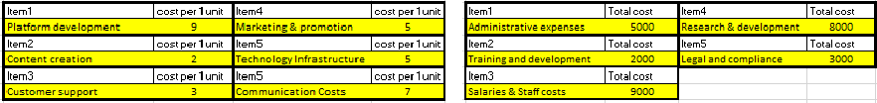

دِّرب دِّرب

|  |
| --- |
| **FINANCIALS REPORT**   The following financial report reflects the company’s performance in its first  year. We are very pleased with the numbers during the first year.  **Aisha Al-Mansouri** |





|  |  |  |
| --- | --- | --- |
| |  | | --- | | **The total cost per unit: (USD)** | | **32.5** |

**5. How much profit do you want to have for each unit? (USD)**

|  |  |
| --- | --- |
| |  | | --- | | 7.5 | |

|  |  |  |
| --- | --- | --- |
| |  | | --- | | **Selling Price: (USD)** | | **40** |
| |  | | --- | | **Break event point:** (number of units) | | |  | | --- | | **3600** | |
| |  | | --- | | **Expected Sales (for all units produced) USD** |  |  | | --- | | **Expected Costs (direct and indirect)** | | |  | | --- | | **720,000** |  |  | | --- | | **585,000** | |

**CAPITAL & Return on Investment ROI**

|  |  |  |
| --- | --- | --- |
| |  | | --- | | **START OF THE COMPANY** | |  |
| |  | | --- | | **The Total Costs to start the company: QAR** | | **585,000** |
| |  | | --- | | **Your Capital or Equity** | | **585,000** |
| **6. How many share you want to have?** | |  | | --- | | 1000 | |
| **Share price: USD** | **585** |

|  |  |  |  |  |  |
| --- | --- | --- | --- | --- | --- |
|  | Total Sales | |  | | --- | | **END OF THE PROGRAM** | | |  | | --- | | 720,000 | |
| Net Profit | 57,056 |
| - | |  | | --- | | **New Share Price** | |  | **720** |
| Return on each share (QAR) | 57.056 |
| **Return on each share % or ROI** | **10%** |

|  |
| --- |
| **11** |



دِّرب دِّرب

|  |  |  |
| --- | --- | --- |
| **PROFIT & LOSS STATEMENT** For the period: 2022 |  |  |
| **Income / Revenue** | **USD** | **TOTAL USD** |
| Sales (revenue from job listings) | 480,320 | **480,320** |
| Sales from Services (if any) | 0 |
| Other Income (if any) | 0 |
| **Total Income or Revenue** |
| **Expenses / Costs** | **USD** | **TOTAL USD** |
| **Variable or Direct costs** | 396,264 | **396,264** |
| Cost of Goods Sold (Direct or variable costs of production) |
| **Fixed or Indirect Costs** | 2000 | **27,000** |
| Training and development |
| Bank Charges | 0 | **423,264** |
| Design costs*\* part of salaries as we have our own team* | 0 |
| Research & development | 8000 |
| Electricity *\* all staff work online from home* | 0 |
| Administrative expenses | 5000 |
| Insurance*\* will be incorporated next year* | 0 |
| Salaries & Staff costs | 9000 |
| Office Supplies & Stationary*\* all staff work online from home* | 0 |
| Postage and Printing | 0 |
| Rent*\* all staff work online from home* | 0 |
| Repairs and Maintenance*\* all staff work online from home* | 0 |
| Telephone*\* all staff work online from home* | 0 |
| Other expenses | 0 |
| **Total Expenses** |
| **Gross Profit/Loss (income)** | **Gross Profit** | **57,056** |

|  |  |  |  |  |  |  |  |  |  |  |  |  |
| --- | --- | --- | --- | --- | --- | --- | --- | --- | --- | --- | --- | --- |
| |  |  |  | | --- | --- | --- | | Interest paid | 0 |  | | Taxes *(based on Jordanian taxes*) | 11,410 |  | |  | | | | **Net Profit/Loss (income)** | **Net Profit** | **45,645** | |

|  |
| --- |
| **12** |

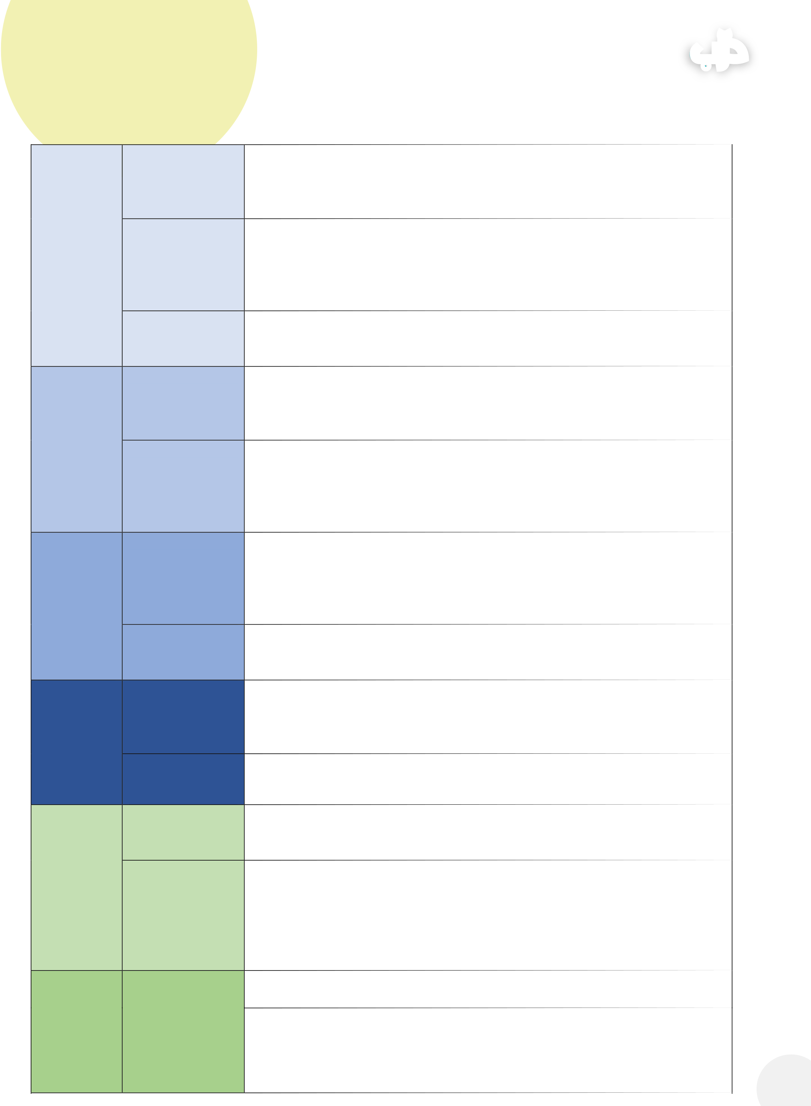

دِّرب دِّرب**BUSINESS PLAN**

|  |  |  |
| --- | --- | --- |
| **What,How** | WHAT do we do? | We provide an online employment networking platform tailored for non- university degree holders, offering job listings, career resources, and networking opportunities to facilitate career development and job placement. |
| **Who** |
| **Why** | HOW do we do it? | Utilizing advanced algorithms, user-friendly interfaces, and personalized  recommendations, our platform matches job seekers with relevant job  opportunities, training programs, and networking events. We offer a seamless user experience, empowering individuals to build their careers and unlock new  opportunities. |
| WHO do we serve? |
| Our target audience includes non-university degree holders, young professionals seeking career advancement, and individuals looking for short- term job opportunities/niche markets or skill development**.** Non-universit y degree holders often face challenges in finding suitable job opportunities and accessing career resourc es tailored to their needs. Traditional job search methods may not cater to their unique skill sets and aspiratio ns, leading to frustration and underemploym**ent.** |
| Define customer |
| **Revenue** | problem | An online platform that addresses this problem by providing a centralized hub for job listings, career resources, and networking opportunities specifically curated for non-degree holders. Through personalized recommendations and tailored support, we empower individuals to navigate their career paths effectively. |
| Define solution |
| We offer a freemium model, allowing users to access basic features for free while offering premium subscription tiers with enhanced features and benefits. Additionally, we may implement a pay-per-post model for employers and partner with educational institutions for revenue sharing opportunities. |
| provided |
| Pricing + Billing |
| Our income streams include subscription fees for premium features, advertising revenue from employers, partnerships with educational institutions, and commissions from training programs or job placements. |
| strategies |
| **Marketing** | Income streams | We will leverage digital marketing channels such as social media, search engine optimization (SEO), email marketing, and paid advertising to reach our target audience. Additionally, partnerships with industry organizations, educational institutions, and employment agencies will expand our reach. |
| Customer reach |
| Implementing referral programs offering incentives for users to refer friends and |
| strategy |
| colleagues will stimulate organic growth and increase user engagement. |
| **Competition** | Referral | Competitors include established job search platforms like Indeed, LinkedIn, and Monster, as well as niche platforms targeting non-degree holders such as WayUp and Snagajob. |
| generation |
| strategy Top |
| competitors |
| Our platform offers a tailored solution specifically designed for non-degree holders, providing personalized recommendations, career resources, and networking opportunities for niche markets and short term employment opportunities that traditional job search platforms may lack. |
| Our competitive | We prioritize user experience and engagement, fostering a supportive community |
| advantage |

focused on career advancement.

|  |  |  |
| --- | --- | --- |
| **Metrics** | Success milestone | Achieve 10,000 registered users within the first six months of launch, with a 20% conversion rate to premium subscriptions. |
| marker 1 |
| Success milestone | Establish partnerships with at least five educational institutions and at least 10 employers from seven different |
| sectors ( administration and office support, transportation and logistics, healthcare support services, constructio |
| marker 2 |
| n and skilled trades, manufacturing & production, hospitality and food services, retail and customer service) within t |

he first year, generating significant revenue through subscription fees and advertising.   
 **13**



**PROJECT MANAGEMENT**دِّرب دِّرب

***Students should (throughout the report), refer to how Project Management***

***essentials were used in creating their Company. NOT INCLUDED IN THIS*** Ensure compliance with data protection laws when collecting and

***REPORT- PLEASE BE SURE TO HIGHLIGHT IT AND MENTION IT THROUGHOUT*** storing user information. Respect user privacy and confidentiality in all networking activities. ***THE REPORT.***  Adhere to industry regulations and ethical standards when partnering with educational institutions, industry influencers, and government agencies.

**SDG & TRACK CONNECTION**  
 **SDG 4-Quality education + SDG 8-Decent work and economic growth** The solution provides unemployed youth with lifelong tools and networks to allow them to continue developing their careers and avoid opting for less decent approaches to financial growth. In addition, there is an element of career development education that the solution will offer that will ensure the sustainability of the advantages of the solution.

**Track: Innovation and Technology***(SDG 9 - Industry, Innovation, and Infrastructure)* One of the key features that would add to the possible sustained success of Darrb is automation and efficiency driven by innovation and technology. Many online employment platforms incorporate automation technology to streamline processes such as job posting, candidate screening, and application management. By automating repetitive tasks, these platforms increase efficiency for both job seekers and employers, reducing the time and effort required to fill vacancies. In addition, advanced online employment platforms use technology to deliver personalized experiences for users based on their preferences, skills, and job search history. By leveraging algorithms and machine learning, these platforms can recommend relevant job opportunities, training programs, and career resources tailored to each user's unique needs and interests.

**REFLECTION**

|  |
| --- |
| **Successes**  1.Market Penetration and User engagement: Darrb successfully penetrated the market and established a strong user base among non-university degree holders seeking employment opportunities. The platform’s user engagement metrics, including active users, job applications, and profile completions exceeded expectations for most of it, indicating a positive response from the target audience.  2. Innovation and Technology Integration: Darrb demonstrated a commitment to innovation and technology integration in its platform development. The incorporation of AI-driven job matching algorithms, personalized career guidance features, and mobile accessibility enhanced the user experience and differentiated the platform from competitors. These technological advancements contributed to attracting and retaining users, positioning the company for future growth. |

|  |
| --- |
| **Areas for Improvement**  1. Sales performance and revenue generation: while achieving 60% of the target sales is a notable accomplishment, there is room for improvement in sales performance and revenue generation. Darrb should assess its sales strategies, customer acquisition channels and pricing models to identify opportunities for optimization and expansion. Implementing targeted marketing campaigns, exploring partnerships with employers, and refining the value proposition could help drive sales growth in the next fiscal year.  2. Customer feedback and satisfaction: Darrb should prioritize gathering customer feedback and monitoring satisfaction levels to ensure a positive user experience. While the platform has attracted users, it’s essential to address any pain points, usability issues, or feature requests identified through user feedback. Establishing channels for feedback collection, conducting user surveys, and implementing iterative improvements based on user insights will help enhance customer satisfaction and loyalty over time. |

|  |
| --- |
| **14** |